;l

Foundations of Programming

Assignment No. : 4
- PROBLEM STATEMENT: Write a C Program to calculate the salary of an employee given his basic pay (taken as input from the user). Calculate gross salary of employee. Let HRA be 10 % of basic pay and TA be 5% of basic pay. Let employees pay professional tax as 2% of total salary. Calculate net salary payable after deductions.

OBJECTIVE:

- To understand the importance of flowchart for any programming model.
- To learn simple flowchart symbols and arrows to define relationships.
- To understand and develop visual representations of flow of data.

THEORY:
- Define Algorithm.

- What are the different characteristics of an algorithm.
PLATFORM: Linux

INPUT:
#include <stdio.h>

int main()
{
float basicPay, hra, ta, grossSalary, professionalTax, netSalary;

printf("Enter Basic Pay: ");
scanf("%f", &basicPay);

hra = 0.10 * basicPay;
ta = 0.05 * basicPay;

grossSalary = basicPay + hra + ta;

professionalTax = 0.02 * grossSalary;

netSalary = grossSalary - professionalTax;

printf("\nBasic Pay : %.2f", basicPay);
printf("\nHRA (10%%) : %.2f", hra);
printf("\nTA (5%%) : %.2f", ta);
printf("\nGross Salary : %.2f", grossSalary);
printf("\nProfessional Tax (2%%) : %.2f", professionalTax);
printf("\nNet Salary Payable : %.2f\n", netSalary);

return 0;
}

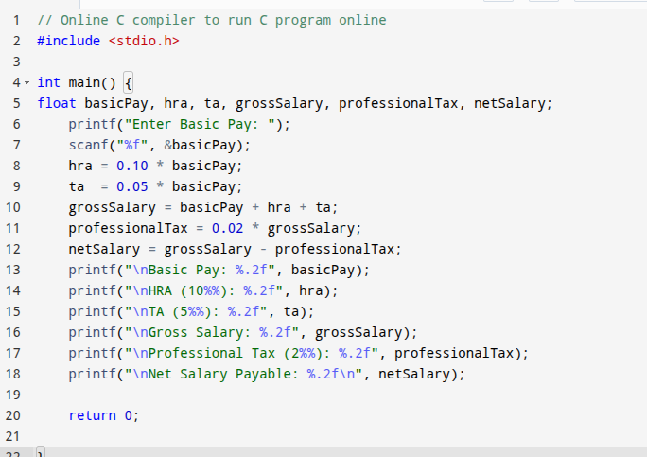
OUTPUT:
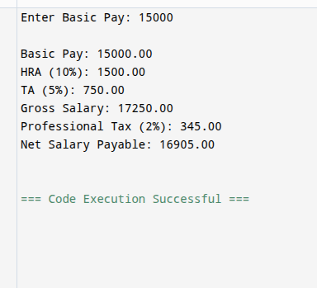
CONCLUSION: Thus, we have learned to write algorithms and to draw its representation in terms of flowchart.

FAQs:
- Describe various symbols and their use in flowchart.
- Difference between Algorithm and Flowchart.

